**PIZZA SALES SQL QUERIES**

**A. KPI’s**

**1. Total Revenue: ---- TOTAL REVENUE**

**SELECT SUM(total_price) AS Total_Revenue**

**FROM pizza_sales**

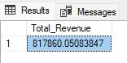

**2. Average Order Value:**

**---- AVERAGE ORDER VALUE**

**SELECT SUM(total_price) / COUNT(DISTINCT(order_id)) AS Average_Order**

**FROM pizza_sales**

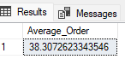

**3. Total Pizza Sold**

**---- TOTAL PIZZA SOLD**

**SELECT SUM(quantity) AS Total_pizza_sold**

**FROM pizza_sales**

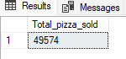

**4. Total Orders**

---- TOTAL ORDERS

SELECT COUNT(DISTINCT(order_id)) AS Total_Orders

FROM pizza_sales

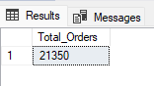

**5. Average Pizza Per Order:** ---- AVERAGE PIZZA PER ORDER

SELECT CAST(CAST(SUM(quantity) AS DECIMAL(10,2)) / CAST(COUNT(DISTINCT(order_id)) AS DECIMAL(10,2)) AS DECIMAL(10,2)) AS Avg_Pizza_Per_Order

FROM pizza_sales

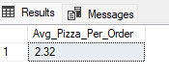

**B. CHART REQUIREMENT**

**1.** **Daily Trends:** ---- DAILY TRENDS

SELECT DATENAME(DW, order_date) AS Order_day, COUNT(DISTINCT(order_id)) AS Total_orders

FROM pizza_sales

GROUP BY DATENAME(DW, order_date)

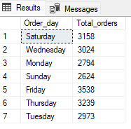

**2. Monthly Trends:** ---- MONTHLY TRENDS

SELECT DATENAME(MONTH, order_date) AS Month_Name, COUNT(DISTINCT(order_id)) AS Total_orders

FROM pizza_sales

GROUP BY DATENAME(MONTH, order_date)

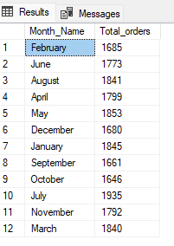

**3. Percentage Pizza Category Per Total Sales**:

SELECT pizza_category, SUM(total_price) * 100

/ (SELECT SUM(total_price) FROM pizza_sales) AS Per_Category_Total_sales

FROM pizza_sales

GROUP BY pizza_category

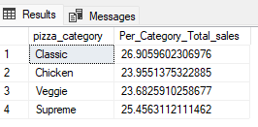

**4. Pizza Category Total Sales And Their Sales With Total Sales:** ---- EACH PIZZA CATEGORY TOTAL SALES

SELECT pizza_category, SUM(total_price) AS Total_price, SUM(total_price) * 100

/ (SELECT SUM(total_price) FROM pizza_sales) AS Per_Category_Total_sales

FROM pizza_sales

GROUP BY pizza_category

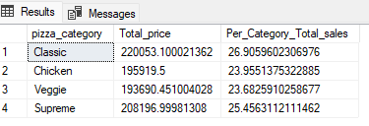

**5. Percentage of Sales Per Pizza Sizes:** ---- PERCENTAGE OF SALES PER PIZZA SIZES

SELECT pizza_size, CAST(SUM(total_price) AS DECIMAL(10,2)) AS total_revenue, CAST(SUM(total_price) * 100 / (SELECT SUM(total_price) FROM pizza_sales) AS DECIMAL(10,2)) AS Perc_Pizza_Sizes

FROM pizza_sales

GROUP BY pizza_size

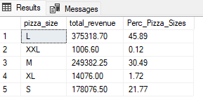

**6. Top 5 Best Selling Pizza When the Total Revenue Are Compared:** ----- TOP 5 BEST SELLING PIZZA WHEN THE TOTAL REVENUE ARE COMPARED

SELECT TOP 5 pizza_name, SUM(total_price) AS Total_Revenue

FROM pizza_sales

GROUP BY pizza_name

ORDER BY Total_Revenue DESC

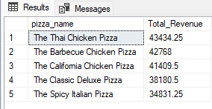

**7. Bottom 5 Best Selling Pizza When the Total Revenue Are Compared:** ----- BOTTOM 5 BEST SELLING PIZZA WHEN THE TOTAL REVENUE ARE COMPARED

SELECT TOP 5 pizza_name, SUM(total_price) AS Total_Revenue

FROM pizza_sales

GROUP BY pizza_name

ORDER BY Total_Revenue

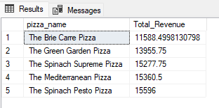

**8. Top 5 Best Selling Pizza When the Total Quantity Are Compared:** SELECT TOP 5 pizza_name, SUM(quantity) AS Total_quantity

FROM pizza_sales

GROUP BY pizza_name

ORDER BY Total_quantity DESC

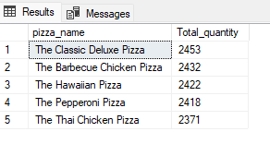

**9. Bottom 5 Best Selling Pizza When the Total Quantity Are Compared:** ----- BOTTOM 5 BEST SELLING PIZZA WHEN THE TOTAL QUANTITY ARE COMPARED

SELECT TOP 5 pizza_name, SUM(quantity) AS Total_quantity

FROM pizza_sales

GROUP BY pizza_name

ORDER BY Total_quantity

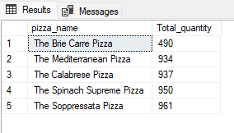

**10. Top 5 Best Selling Pizza When the Total Orders Are Compared:** ----- TOP 5 BEST SELLING PIZZA WHEN THE TOTAL ORDER ARE COMPARED

SELECT TOP 5 pizza_name, COUNT(DISTINCT(order_id)) AS Total_orders

FROM pizza_sales

GROUP BY pizza_name

ORDER BY Total_orders DESC

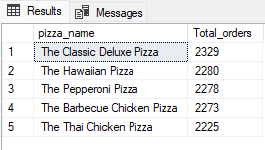

**11. Bottom 5 Best Selling Pizza When the Total Orders Are Compared:** ----- TOP 5 BEST SELLING PIZZA WHEN THE TOTAL ORDER ARE COMPARED

SELECT TOP 5 pizza_name, COUNT(DISTINCT(order_id)) AS Total_orders

FROM pizza_sales

GROUP BY pizza_name

ORDER BY Total_orders DESC

